Home work solution (chapters 8-14)
Chapter 8: P283:E4
4. Develop a resource schedule in the loading chart that follows. Use the parallel method and heuristics given. Be sure to update each period as the computer would do. Note: Activities 2, 3, 5, and 6 use two of the resource skills. Three of the resource skills are available.

Log of Parallel Method of Scheduling Exercise 8-4

PERIOD | ACTIVITY | CHANGES
0-1 | 2 | Schedule Activity 2 (first by minimum slack rule)
 | 1 | Schedule Activity 1
1-2 | - | No changes
2-3 | - | No changes
3-4 | - | No changes
4-5 | 3 | Delay ES of Activity 3 to 5. Reduce slack to 1
5-6 | 4 | Schedule Activity 4 (minimum slack rule)
 | 3 | Schedule Activity 3
 | 5 | Delay ES of Activity 5 to 6. Reduce slack to 1
6-7 | 5 | Delay ES of Activity 5 to 7. Reduce slack to 0
7-8 | 5 | Delay ES of Activity 5 to 8. Reduce slack to -1
 | 6 | Delay ES of Activity 6 to 11. Reduce slack to -1
8-9 | 5 | Delay ES of Activity 5 to 9. Reduce slack to -2
 | 6 | Delay ES of Activity 6 to 12. Reduce slack to -2
9-10 | 5 | Schedule Activity 5
10-11 | - | No changes
11-12 | - | No changes
12-13 | 6 | Schedule Activity 6
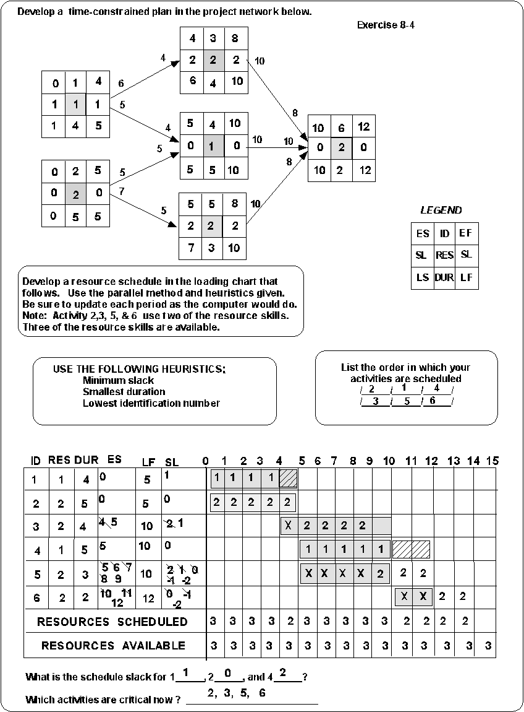

Chapter 9: P326:E4
4. If the indirect costs for each duration are $1,200 for 16 weeks, $1,130 for 15 weeks, $1,000 for 14 weeks, $900 for 13 weeks, $860 for 12 weeks, $820 for 11 weeks and $790 for 10 weeks, compute the total costs for each duration. Plot these costs on a graph. What is the optimum cost-time schedule?

Note: The duration for this schedule is weeks and students should be told only to crash the network one week at a time (not days).

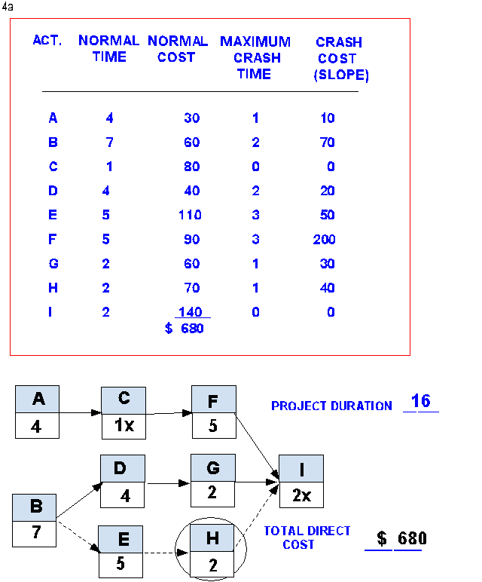

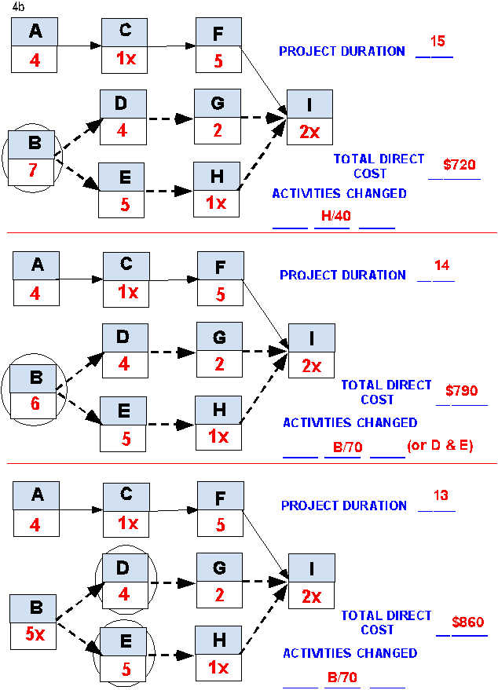

For duration 14, B is chosen over D & E because it is the earliest task. If problems occur, you can crash D or E.

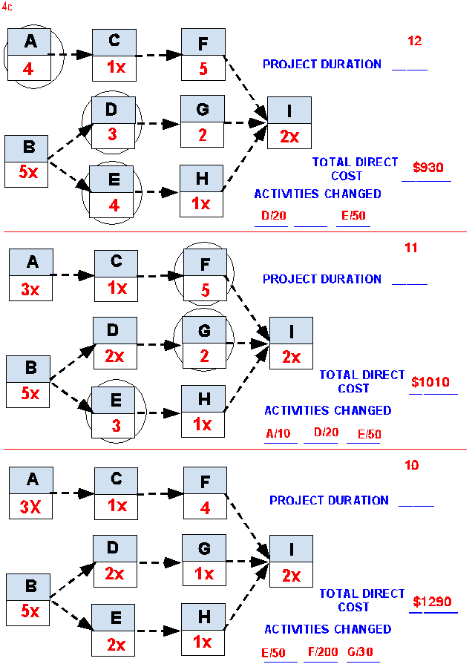

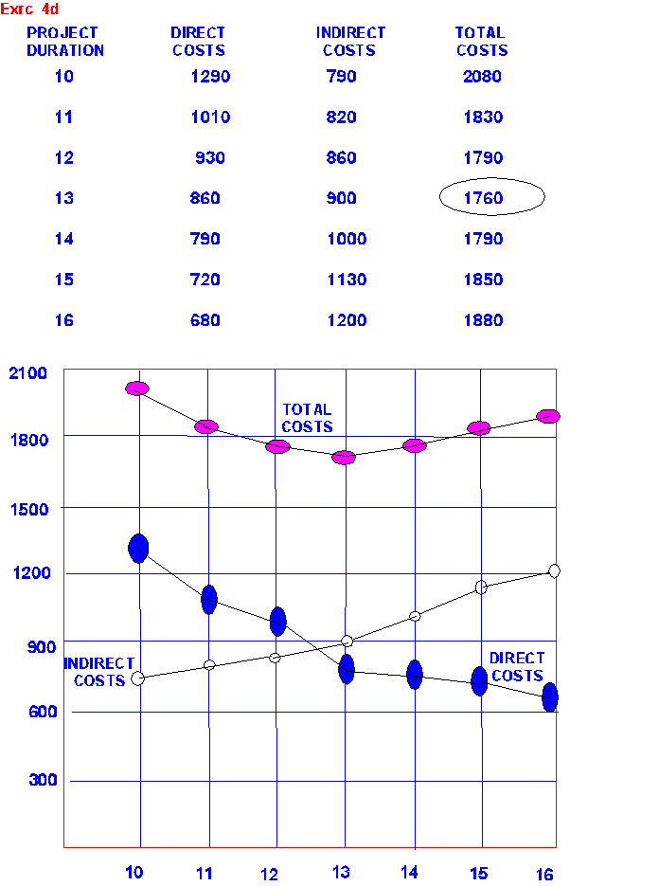

Chapter 13: Page 490, Exercise 6
6. The following labor hours data have been collected for a nanotechnology project for periods 1 through 6. Compute the SV, CV, SPI, and CPI for each period. Plot the EV and the AC on the summary graph provided (or a similar one). Plot the SPI, CPI and PCIB on the index graph provided (or a similar one). What is your assessment of the project at the end of period 6?

After 6 time periods the project is roughly 66% complete and so far work on the project has taken 1,600 hours less work than planned. There is 400 hours worth of work on Activity 4 which was suppose to have been done that has not done. Since Activity 4 is on the critical path, the project is behind schedule. If schedule is the number priority, the project manager may want to consider investing some of the savings on accelerating critical activities.

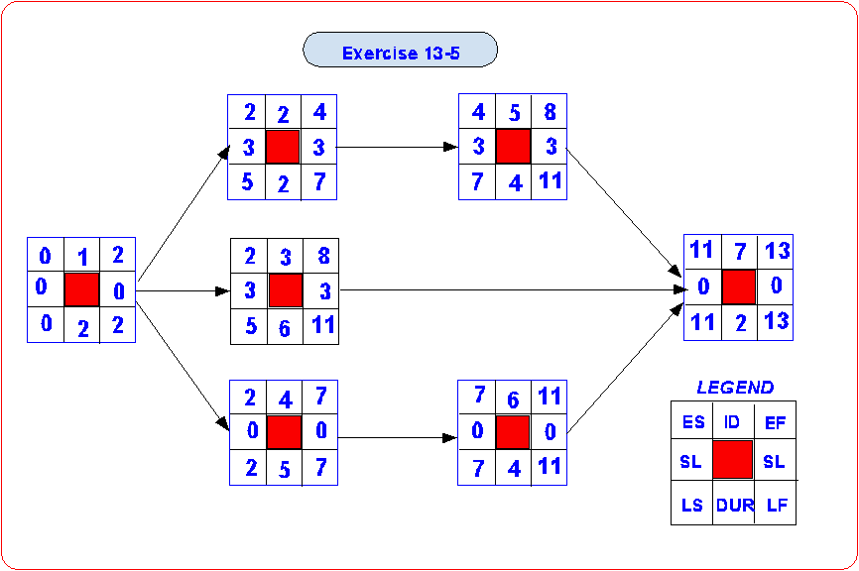

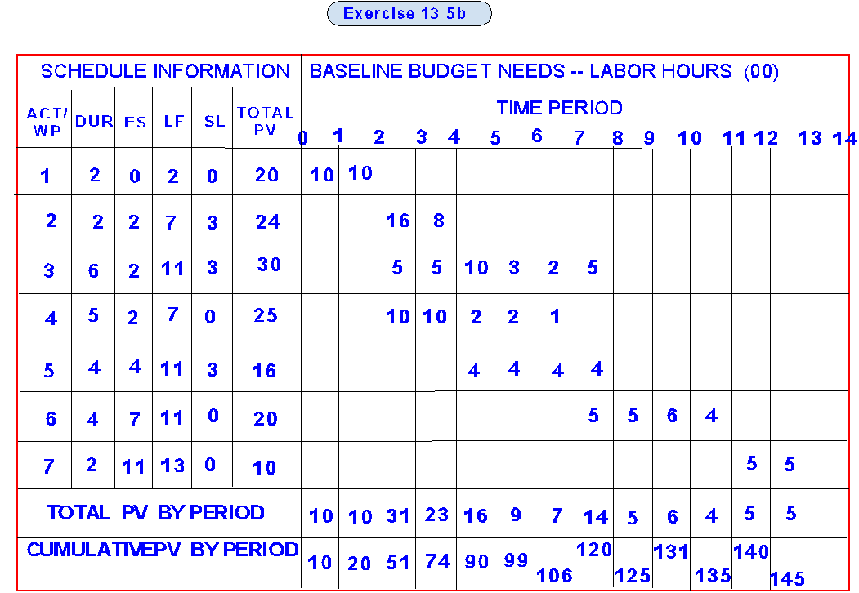

Status Report: Ending Period 1
Task | % Complete | EV | AC | PV | CV | SV
1 | 50% | 1000 | 500 | 1000 | +500 | 0
Cumulative Totals |  | 1000 | 500 | 1000 | +500 | 0

Status Report: Ending Period 2
Task | % Complete | EV | AC | PV | CV | SV
1 | Finished | 2000 | 1500 | 2000 | +500 | 0
Cumulative Totals |  | 2000 | 1500 | 2000 | +500 | 0

Status Report: Ending Period 3
Task | % Complete | EV | AC | PV | CV | SV
1 | Finished | 2000 | 1500 | 2000 | +500 | 0
2 | 0% | 0 | 0 | 1600 | 0 | -1600
3 | 10% | 300 | 200 | 500 | +100 | -200
4 | 20% | 500 | 500 | 1000 | 0 | -500
Cumulative Totals |  | 2800 | 2200 | 5100 | +600 | -2300

Status Report: Ending Period 4
Task | % Complete | EV | AC | PV | CV | SV
1 | Finished | 2000 | 1500 | 2000 | +500 | 0
2 | 50% | 1200 | 1000 | 2400 | +200 | -1200
3 | 30% | 900 | 800 | 1000 | +100 | -100
4 | 40% | 1000 | 1500 | 2000 | -500 | -1000
Cumulative Totals |  | 5100 | 4800 | 7400 | +300 | -2300

Status Report: Ending Period 5
Task | % Complete | EV | AC | PV | CV | SV
1 | Finished | 2000 | 1500 | 2000 | +500 | 0
2 | Finished | 2400 | 2000 | 2400 | +400 | 0
3 | 50% | 1500 | 800 | 2000 | +700 | -500
4 | 60% | 1500 | 1500 | 2200 | 0 | -700
5 | 25% | 400 | 400 | 400 | 0 | 0
Cumulative Totals |  | 7800 | 6200 | 9000 | +1600 | -1200

Status Report: Ending Period 6
Task | % Complete | EV | AC | PV | CV | SV
1 | Finished | 2000 | 1500 | 2000 | +500 | 0
2 | Finished | 2400 | 2000 | 2400 | +400 | 0
3 | 80% | 2400 | 2100 | 2300 | +300 | +100
4 | 80% | 2000 | 1800 | 2400 | +200 | -400
5 | 50% | 800 | 600 | 800 | +200 | 0
Cumulative Totals |  | 9600 | 8000 | 9900 | +1600 | -300

Indexes
Period | SPI | CPI | PCIB
1 | 1.00 | 2.00 | .07
2 | 1.00 | 1.33 | .14 | SPI = EV / PV
3 | .55 | 1.27 | .19 | CPI = EV / AC
4 | .69 | 1.06 | .35 | PCIB = EV / BAC
5 | .87 | 1.26 | .54
6 | .96 | 1.20 | .66



